ECE 320

Discrete Time Signals

Fall 2013

Matlab # 1

Professor John Buck

Arnold Mukasa

__________________

Daniel Noyes:

__________________

Problem 2.7 :

a.)
Code:
%Problem(a)
disp('Problem (a)')

len = 10;

n = -len:len;
x = (n == 0) + (n == 2);

h = 2*(n == -1) - 2*(n == 1);

%y = x*h;
y = conv(x,h);

ny = -(len*2):(len*2);
figure(1);
stem(ny,y)
title('y[n] = h[n]*x[n]');
xlabel('n (samples)');
ylabel('y[n]');
Output:
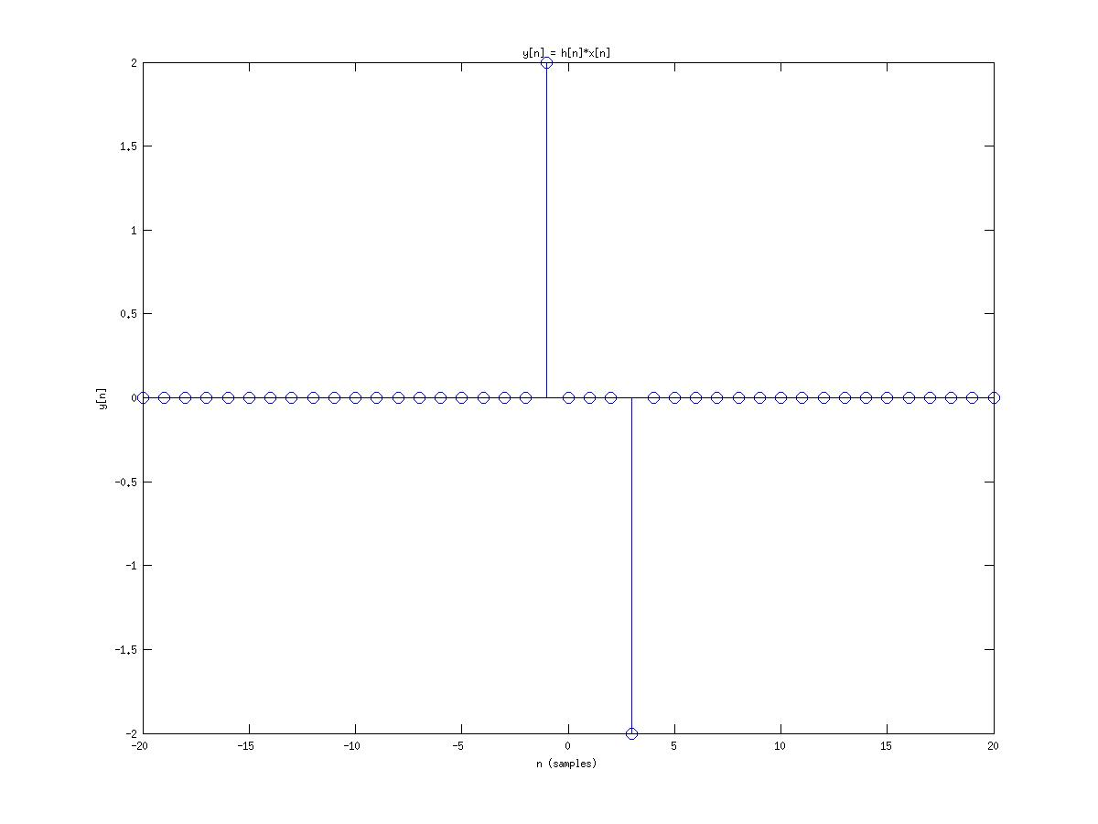
Figure 2.7a1

b.)
Code:
%Problem(B)
disp('Problem (b)')
%N = 10;
%M = 20;
N = input('Enter N:');
M = input('Enter M:');
a = 0;
b = N - 1;
c = 0;
d = M - 1;

nh = a:b;
nx = c:d;

h = imp(nh - a) + imp(nh - b);
x = imp(nx - c) + imp(nx - d);

figure(1);
subplot(211)
stem(nx,x)
title('Input Signal for Problem 2.7b');
xlabel('Time (samples)');
ylabel('x[n]');

subplot(212)
stem(nh,h)
title('Impulse response for Problem 2.7b');
xlabel('Time (samples)');
ylabel('h[n]');

%find the convolution
y = conv(h,x);
disp('y length')
length(y)
ny = (a+c): (b+d);

figure(2);
stem(ny,y)
title('y[n] = h[n]*x[n]');
xlabel('Time (samples)');
ylabel('y[n]');
Output: For N = 20, M = 10
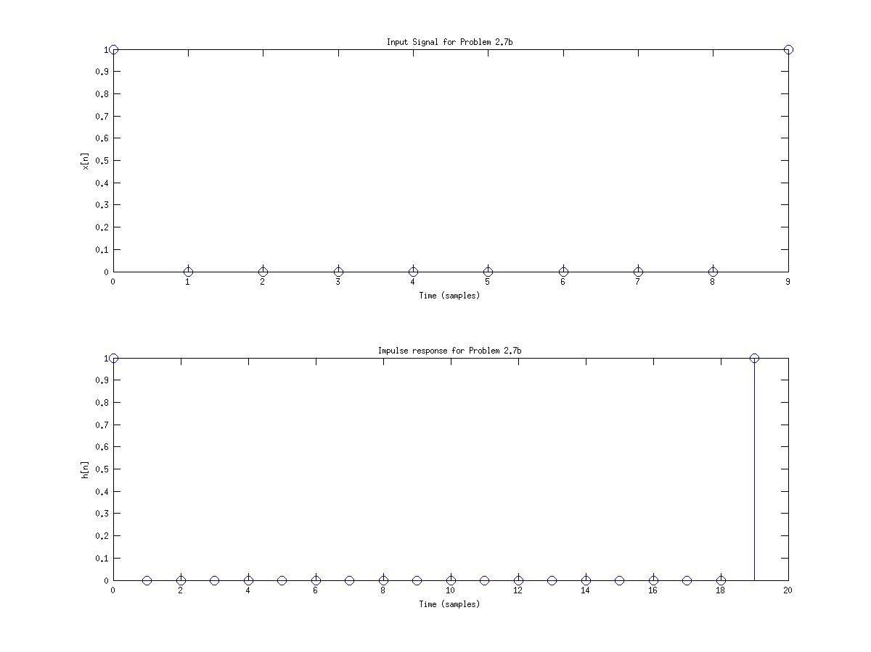
Figure(2.7b1)

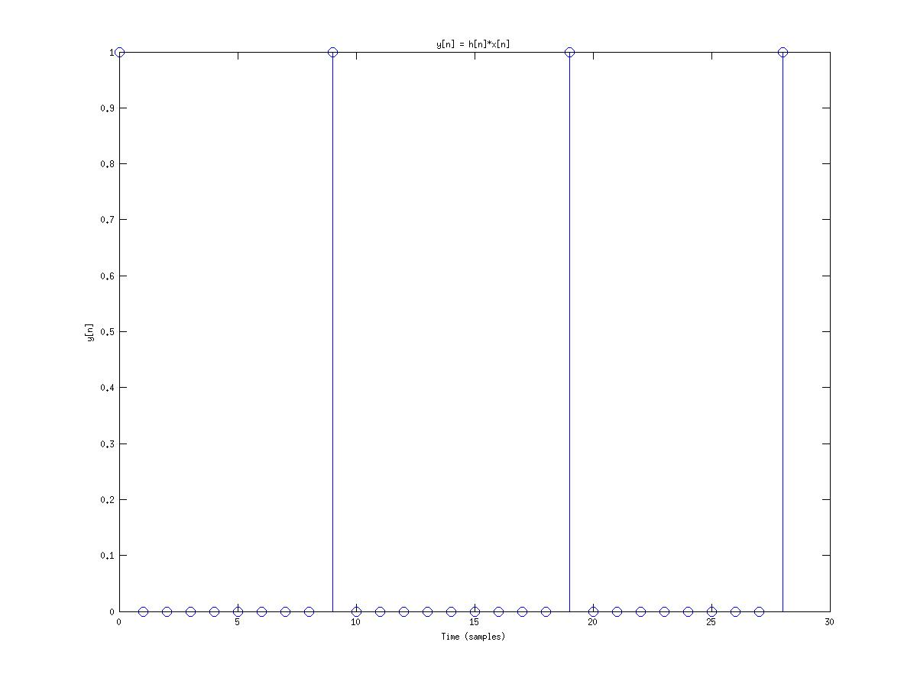
Figure(2.7b2)

In this Problem you consider two finite length sequences and check with the length of y[n] =(M + N -1). In this section you have to prove that both sequences h[n] and x[n] with h length be a to b and x from c to d. When you analyse the conv function you notice that the only compute up to Nx + Nh -1 samples so the output of the new converged function y[n] will have a length of number of h and x together minus 1. since both have a variable length of h:a-b and x:c-d we can see that the new n length is from (a+c) to (b+d) which turns out to be both length added together minus 1.

c.)
Code:
%Problem(c)
disp('Problem (c)')

a = 0;
b = 24;
c = -2;
d = 14;

nx = a:b;
nh = c:d;

x = (1/2).^(nx - 2) .* Heaviside(nx -2);
h = Heaviside(nh+2);

figure(1);
subplot(211)
stem(nx,x)
title('Input Signal for Problem 2.7c');
xlabel('Time (samples)');
ylabel('x[n]');

subplot(212)
stem(nh,h)
title('Impulse response for Problem 2.7c');
xlabel('Time (samples)');
ylabel('h[n]');

%find the convolution
y = conv(h,x);
ny = (a+c): (b+d);

figure(2);
stem(ny,y)
title('y[n] = h[n]*x[n]');
xlabel('Time (samples)');
ylabel('y[n]');
Output:
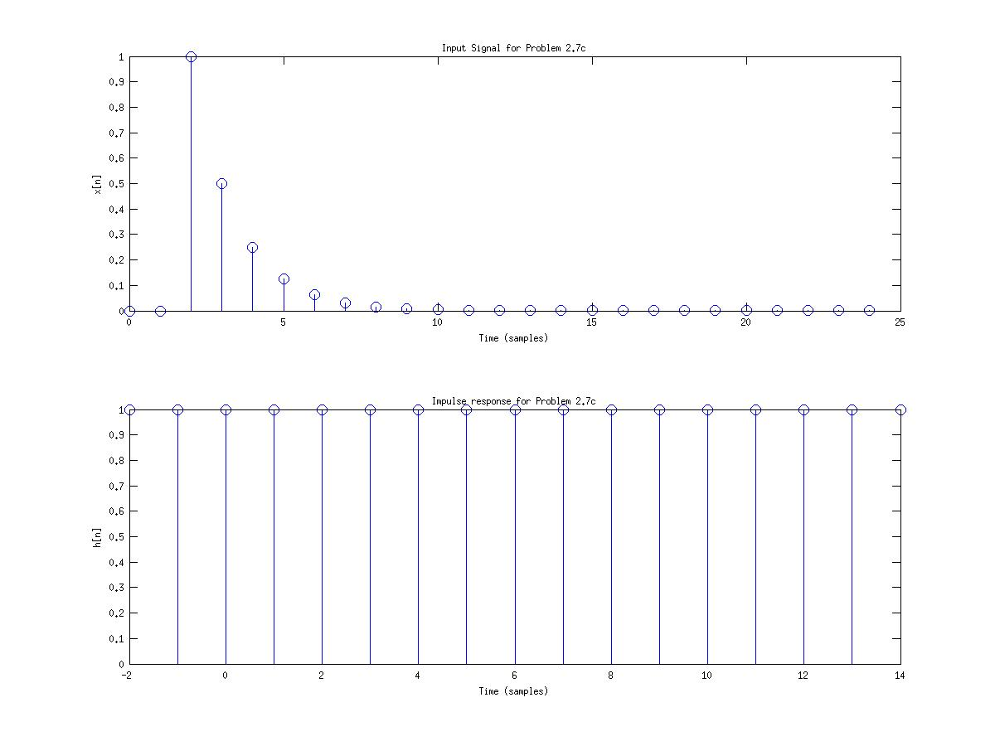
figure(2.7c1)
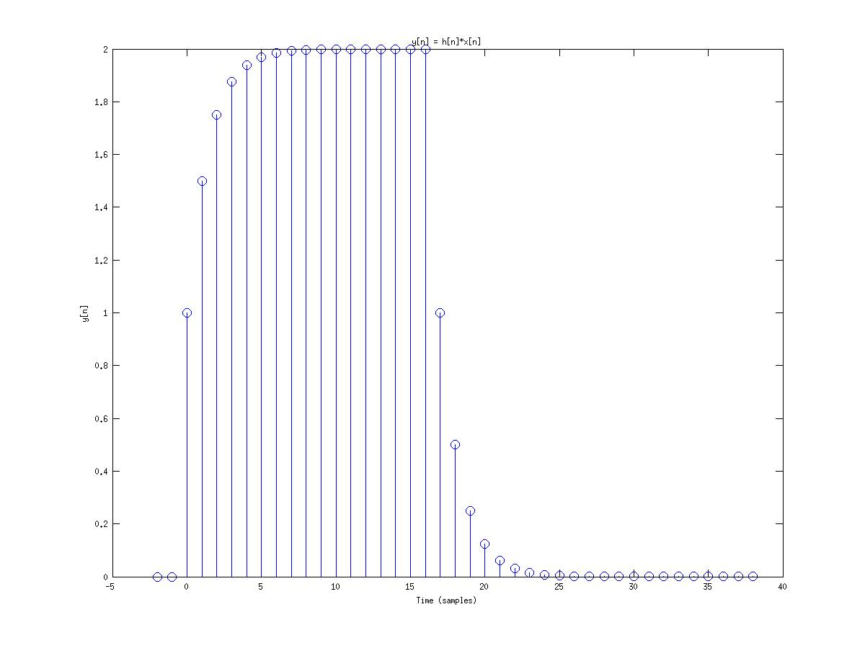
figure( 2.7c2)

d.)
Code:
Output
%Problem(d)
disp('Problem (d)')

n = 0:99;

x = cos(n.^2).*sin(2*pi.*n/5).*Heaviside(n);
h = (0.9).^(n) .*(Heaviside(n) - Heaviside(n-10));

figure(1);
subplot(211)
stem(n,x)
title('Input Signal for Problem 2.7d');
xlabel('Time (samples)');
ylabel('x[n]');

subplot(212)
stem(n,h)
title('Impulse response for Problem 2.7d');
xlabel('Time (samples)');
ylabel('h[n]');

%find the convolution
y = conv(h,x);
ny = n(1)*2: n(end)*2;

figure(2);
stem(ny,y)
xlim([n(1) n(end)]);
title('y[n] = h[n]*x[n]');
xlabel('Time (samples)');
ylabel('y[n]');
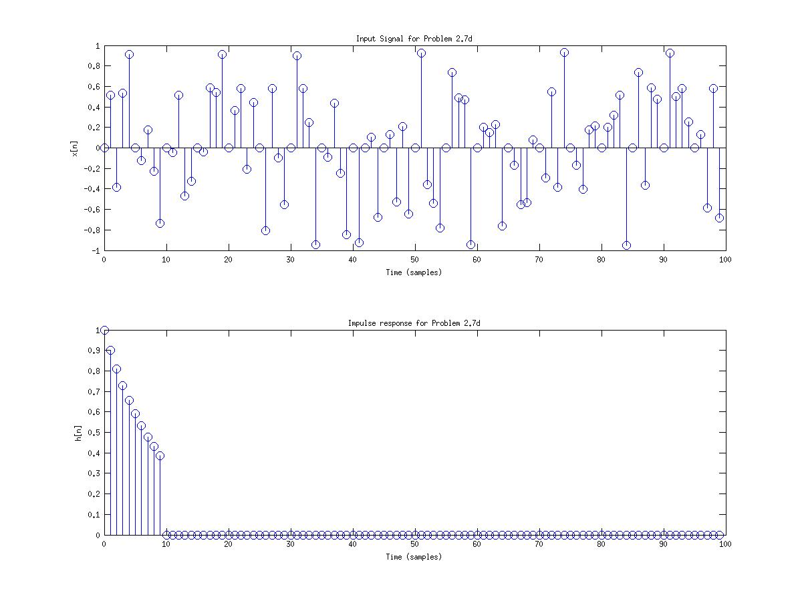
figure(2.7d1)
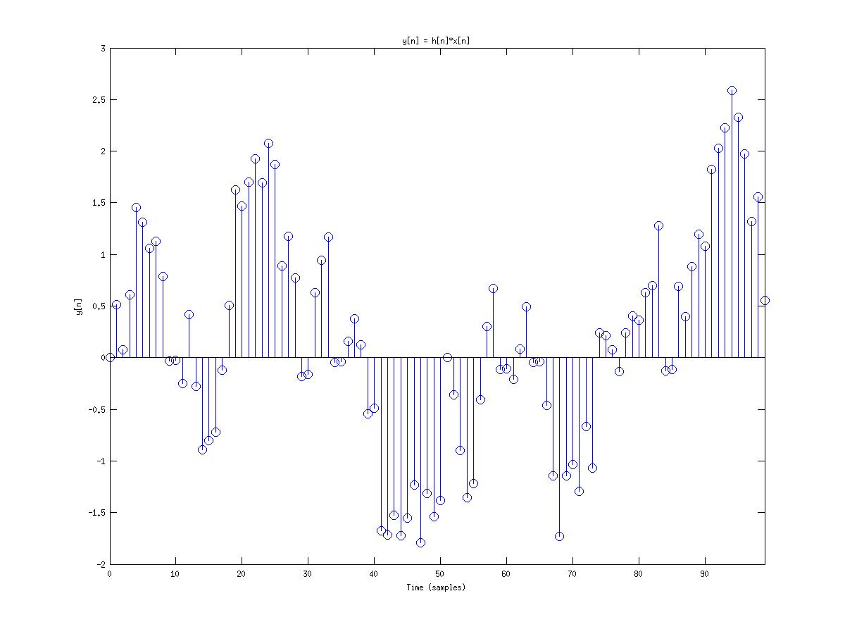
figure(2.7d2)

e.)
Code
:
%Problem(e)
disp('Problem (e)')

L = 50;
n = 0:99;

x = cos(n.^2).*sin(2*pi.*n/5).*Heaviside(n);
h = (0.9).^(n) .*(Heaviside(n) - Heaviside(n-10));

x0 = x(1:L);
x1 = x(L+1:2*L);

n0 = n(1:L);
n1 = n(L+1:2*L);

figure(1);
subplot(211)
stem(n,x)
title('Input Signal for Problem 2.7e');
xlabel('Time (samples)');
ylabel('x[n]');

subplot(212)
stem(n,h)
title('Impulse response for Problem 2.7e');
xlabel('Time (samples)');
ylabel('h[n]');

%find the convolution
y = conv(h,x);
ny = n(1)*2: n(end)*2;

figure(2);
stem(ny,y)
xlim([n(1) n(end)]);
title('y[n] = h[n]*x[n]');
xlabel('Time (samples)');
ylabel('y[n]');

%seperated finite-length impulse

figure(3);
subplot(211)
stem(n0,x0)
title('Input Signal x0 for Problem 2.7e');
xlabel('Time (samples)');
ylabel('x[n]');

subplot(212)
stem(n1,x1)
title('Input Signal x1 for Problem 2.7e');
xlabel('Time (samples)');
ylabel('h[n]');
%find the convolution of the seperate parts and add them together
y0 = conv(h,x0);
ny0 = n0(1): (n0(end)*2+L);

y1 = conv(h,x1);
ny1 = n1(1): (n1(end)*2);

nyy = ny0(1)*2: ny1(end);
yy = zeros(1, length(nyy));

%go through and add all the data together
for i = 1: length(yy)

if(i <= L)
yy(i) = y0(i);
else
if(i < length(y0))
yy(i) = y0(i) + y1(i-L);
else
yy(i) = y1(i-L);
end
end

end

figure(4);
subplot(211)
stem(ny0,y0)
title('y0[n] = h[n]*x0[n]');
xlabel('Time (samples)');
ylabel('y[n]');

subplot(212)
stem(ny1,y1)
title('y1[n] = h[n]*x1[n]');
xlabel('Time (samples)');
ylabel('y[n]');

figure(5)
stem(nyy,yy)
xlim([0 99]);
title('y[n] = y0[n] + y1[n]');
xlabel('Time (samples)');
ylabel('y[n]');
Output:
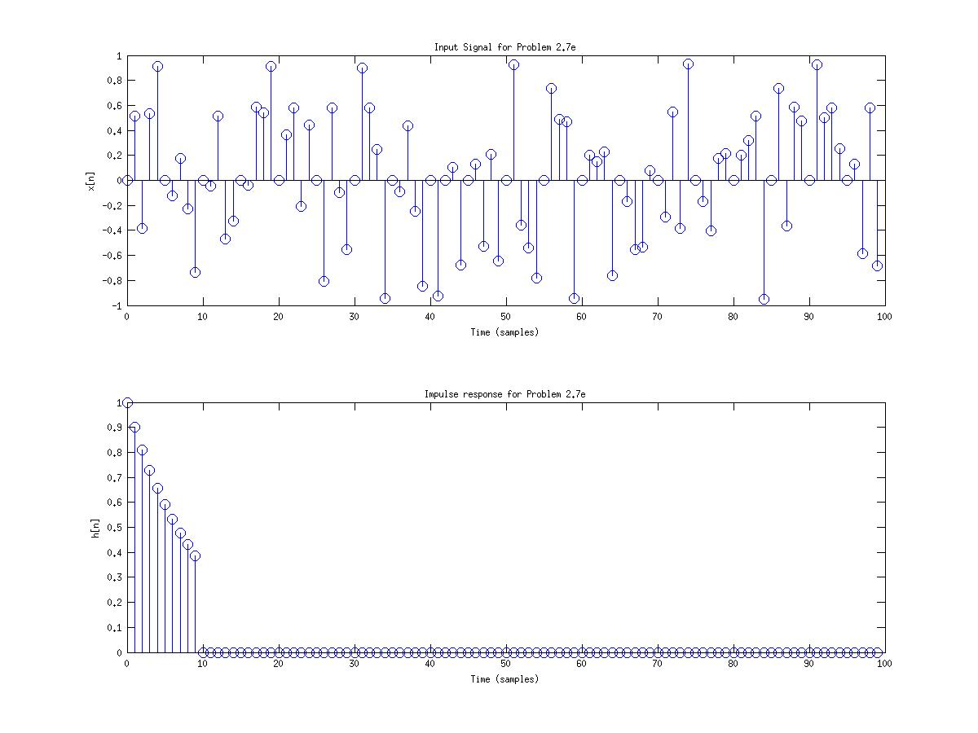
figure(2.7e1)
figure(2.7e2)
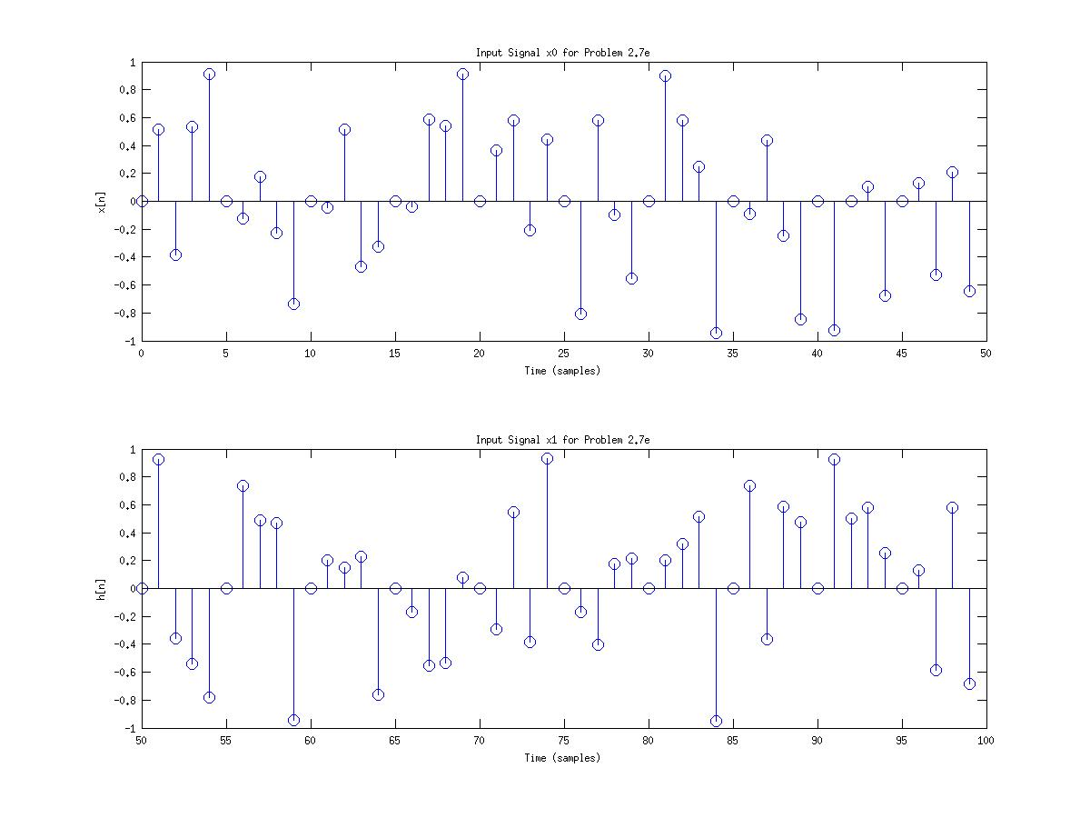
figure(2.7e3)
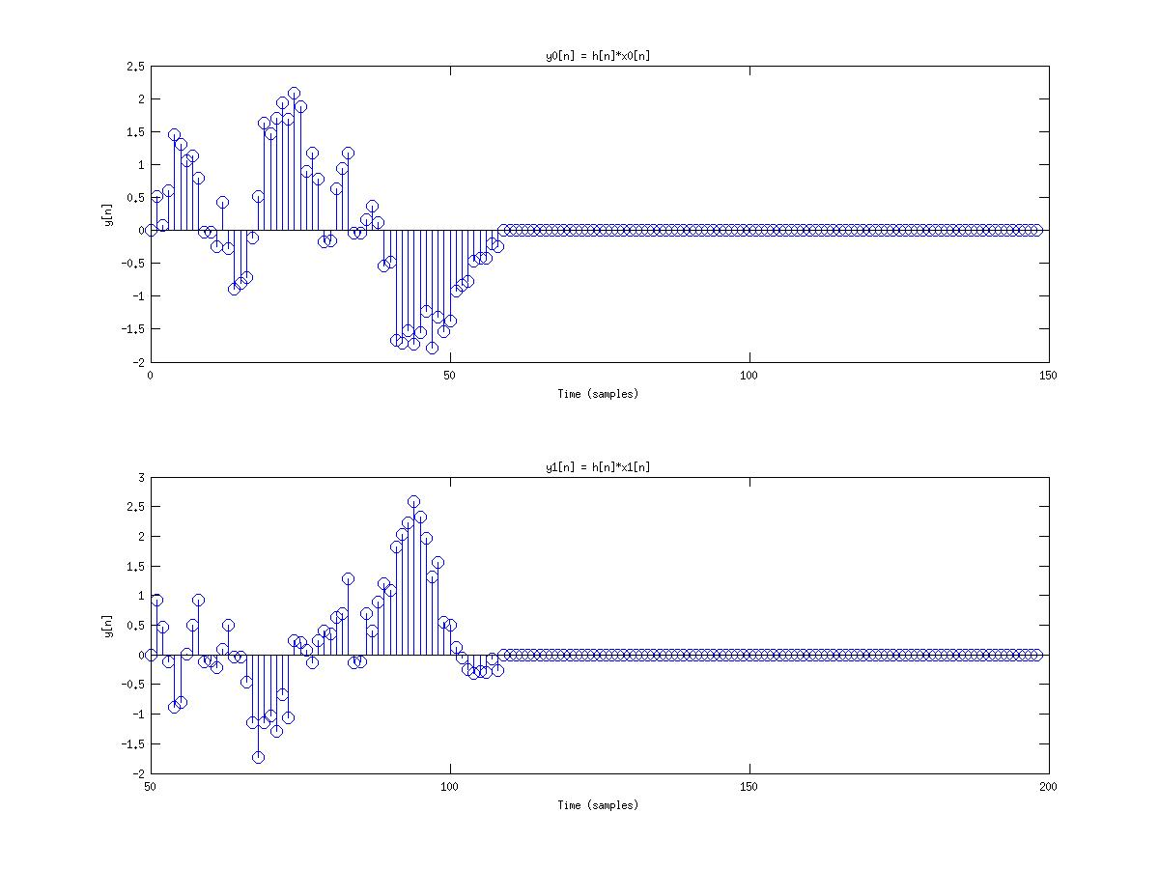
figure(2.7e4)
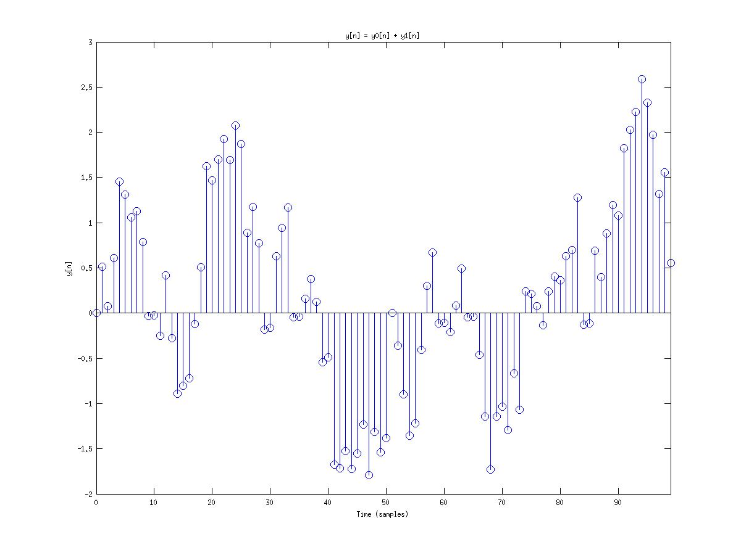
figure(2.7e5)

Problem 2.10 :

a.)
Code:
%Problem 2.10 (a)

disp('Problem 2.10(a)')

load lineup.mat;
N = 1000;
a = 0.5;

he = [1, zeros(1,N-1-length(a)), a];

stem(he)
title('Impluse response of the echo system')
xlabel('Time (samples)')
ylabel('he[n]')
Output:
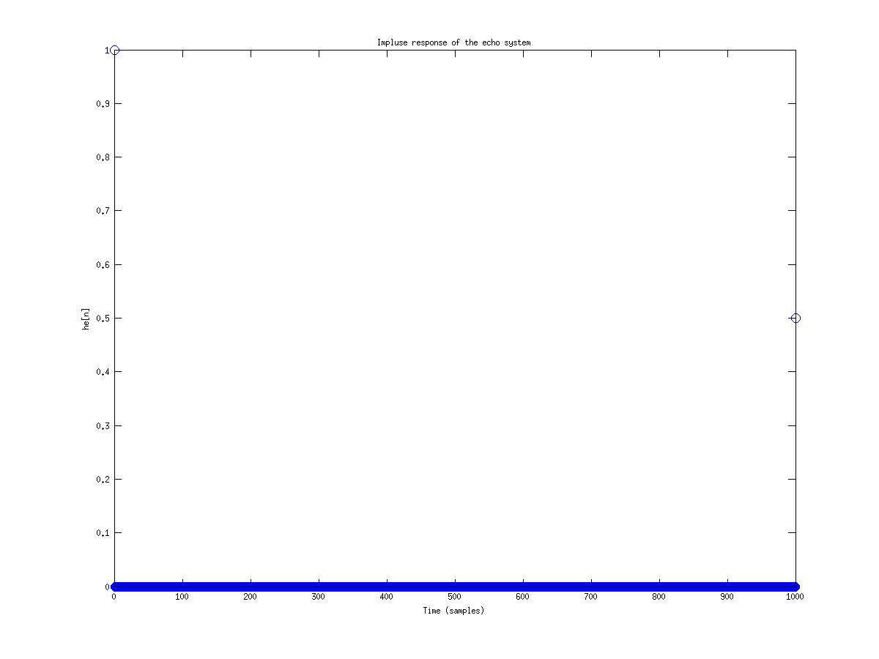
figure(2.10a)

b.)

With the position of both z and y we can see that at point N, both signal x and z would overlap and effectively remove the echo.

c.)
Code:
%Problem 2.10 (c)
disp('Problem 2.10(c)')

load lineup.mat;
N = 1000;
a = 0.5;

b = [1, zeros(1,N-1-length(a)), a];
d = [1, zeros(1,4000)];
her = filter(1,b,d);

stem(her)
title('Impluse response using filter')
xlabel('Time (samples)')
ylabel('her[n]')
Output:
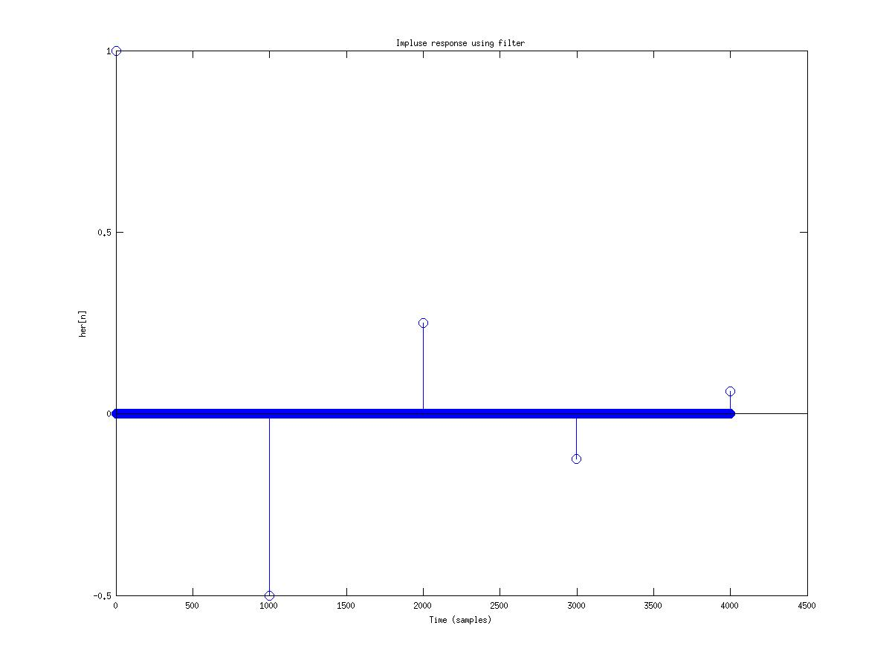
figure(2.10c)

d.)
Code:
%Problem 2.10 (d)
disp('Problem 2.10(d)')

load lineup.mat;
N = 1000;
alpha = 0.5;

a = [1, zeros(1,N-1-length(alpha)), alpha];
d = [1, zeros(1,4000)];
her = filter(1,a,d);

z = filter(1,a,y);

figure(1)
plot(z)
title('Echo removed system')
xlabel('Time')
ylabel('z')

sound(z,8192)
Output:
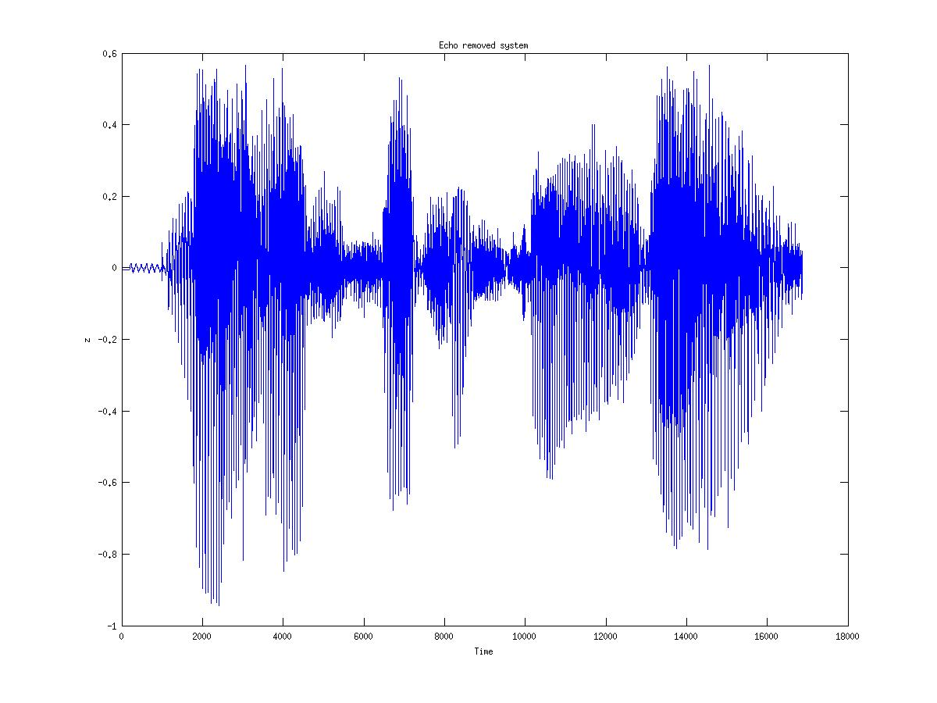
figure(2.10d)

e.)
Code:
%Problem 2.10 (e)
disp('Problem 2.10(e)')

load lineup.mat;
N = 1000;
alpha = 0.5;

he = [1, zeros(1,N-1-length(alpha)), alpha];

a = [1, zeros(1,N-1-length(alpha)), alpha];
d = [1, zeros(1,4000)];
her = filter(1,a,d);

hoa = conv(he,her);
figure(1)
plot(hoa)
title('Convolving he with her')
xlabel('Time')
ylabel('hoa')
Output:
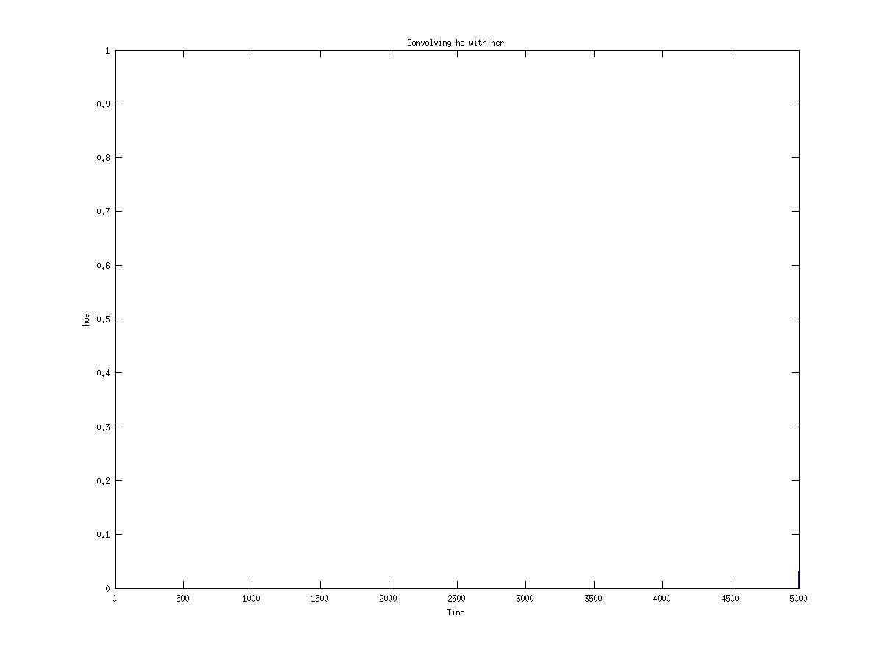
figure(2.10e)
After convolving he with her, the data shows only one fluctuation at time n.

Problem 3.4 :

a.)
Code:
%Problem 3.4 (a)

disp('Problem 3.4(a)')

n = -20:100;
x1 = exp(j*(pi/4)*n);
x2 = sin(n*(pi/8) + pi/16);
x3 = (9/10).^n;
x4 = n+1;

figure(1)
subplot(211)
stem(n,real(x1));
title('real part for X1 [exp(j*(pi/4)*n)]')
xlabel('Time')
ylabel('imag x1')

subplot(212)
stem(n,imag(x1));
title('Imaginary part of X1[exp(j*(pi/4)*n)]')
xlabel('Time')
ylabel('imag x1')

figure(2)
stem(n,x2);
title('Signal of X2 [sin(n*(pi/8) + pi/16)]')
xlabel('Time')
ylabel('X2[n]')

figure(3)
stem(n,x3);
title('Signal of X3 [(9/10).^n]')
xlabel('Time')
ylabel('X3[n]')

figure(4)
stem(n,x4);
title('Signal of X4 [n+1]')
xlabel('Time')
ylabel('X4[n]')
Output:
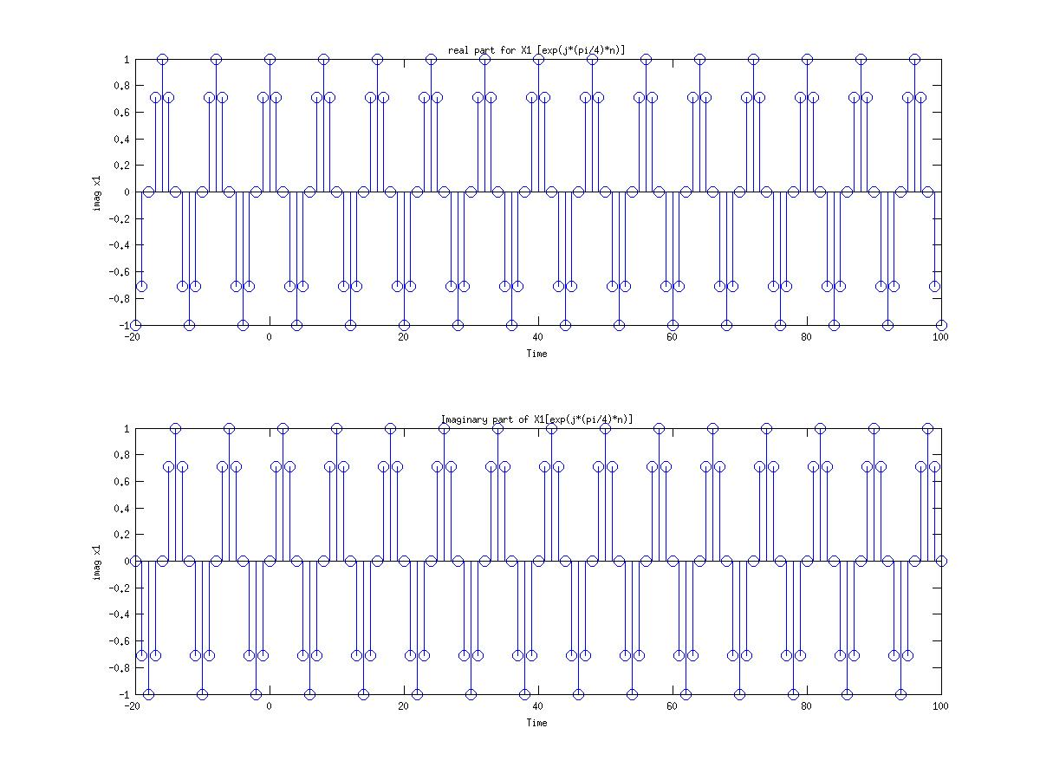
figure(3.4a1)
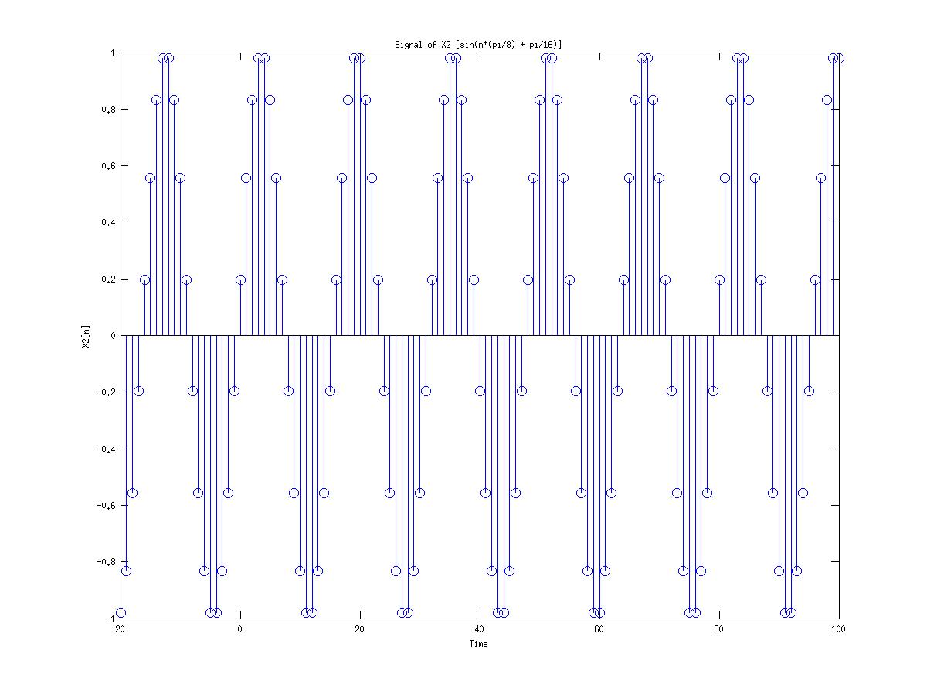
figure(3.4a2)
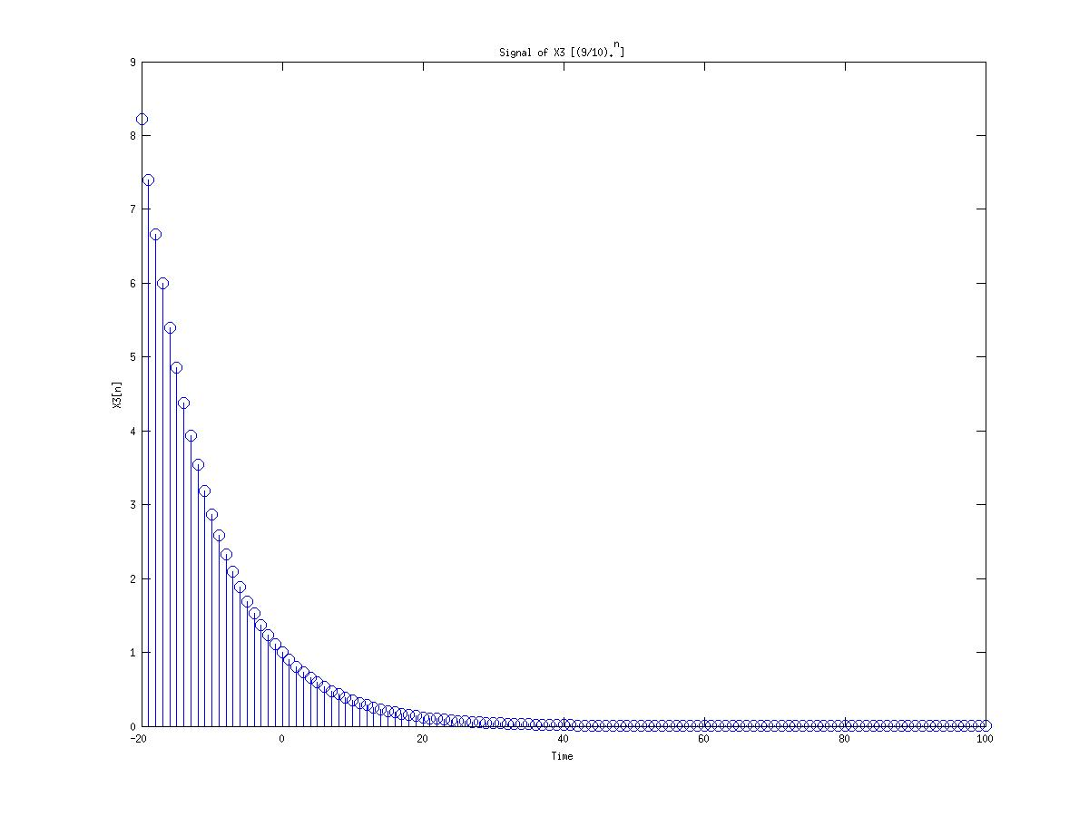
figure(3.4a3)
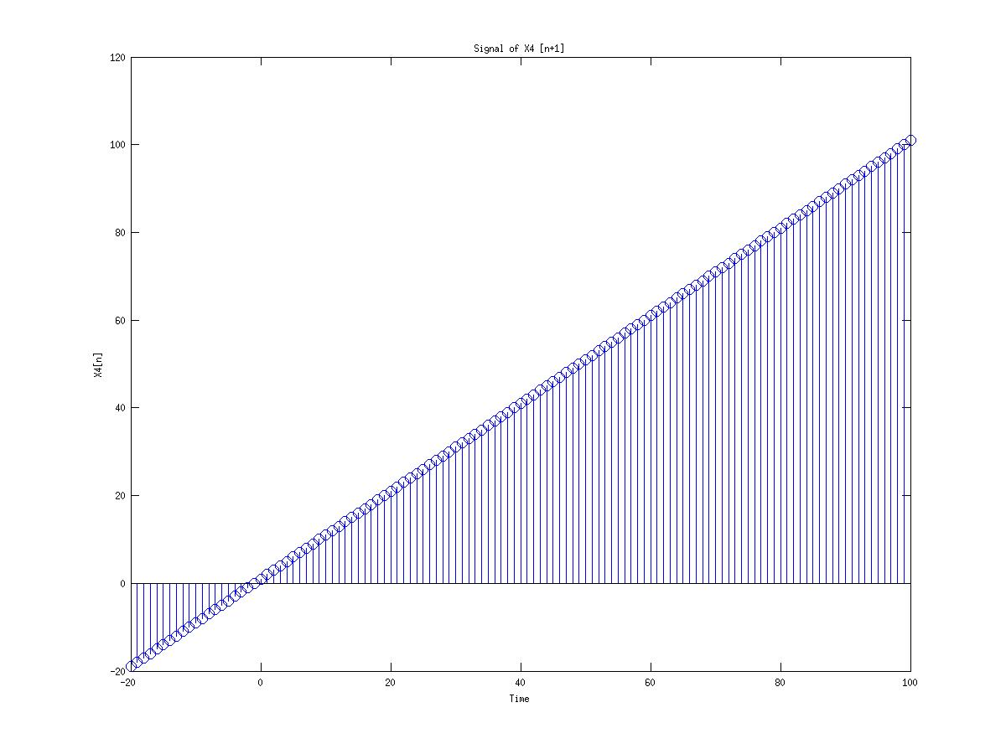
figure(3.4a4)

b.)
Code:
%Problem 3.4 (b)

disp('Problem 3.4(b)')

n = -20:100;
x1 = exp(j*(pi/4)*n);
x2 = sin(n*(pi/8) + pi/16);
x3 = (9/10).^n;
x4 = n+1;

a = [1 -0.25];
b = [1 0.9];

%calculate the y function from the constant-coefficient edifference equation
y1 = filter(a,b,x1);
y2 = filter(a,b,x2);
y3 = filter(a,b,x3);
y4 = filter(a,b,x4);

figure(1)
subplot(211)
stem(n,real(y1));
title('Filtered Signal of real part for Y1')
xlabel('Time')
ylabel('imag x1')

subplot(212)
stem(n,imag(y1));
title('Filtered Signal of Imaginary part of Y1')
xlabel('Time')
ylabel('imag x1')

figure(2)
stem(n,y2);
title('Filtered Signal of Y2')
xlabel('Time')
ylabel('X2[n]')

figure(3)
stem(n,y3);
title('Filtered Signal of Y3')
xlabel('Time')
ylabel('X3[n]')

figure(4)
stem(n,y4);
title('Filtered Signal of Y4')
xlabel('Time')
ylabel('X4[n]')
Output:
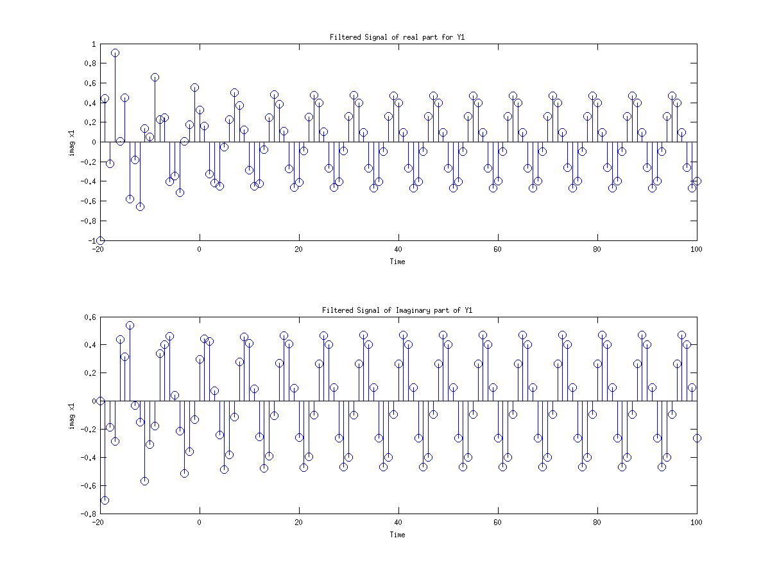
figure(3.4b1)
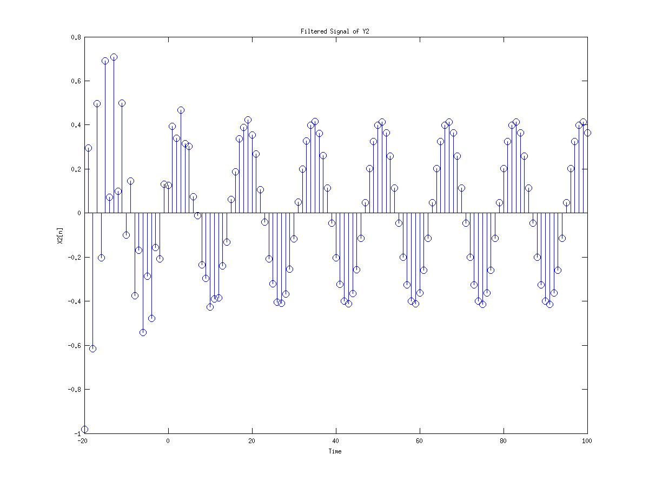
figure(3.4b2)
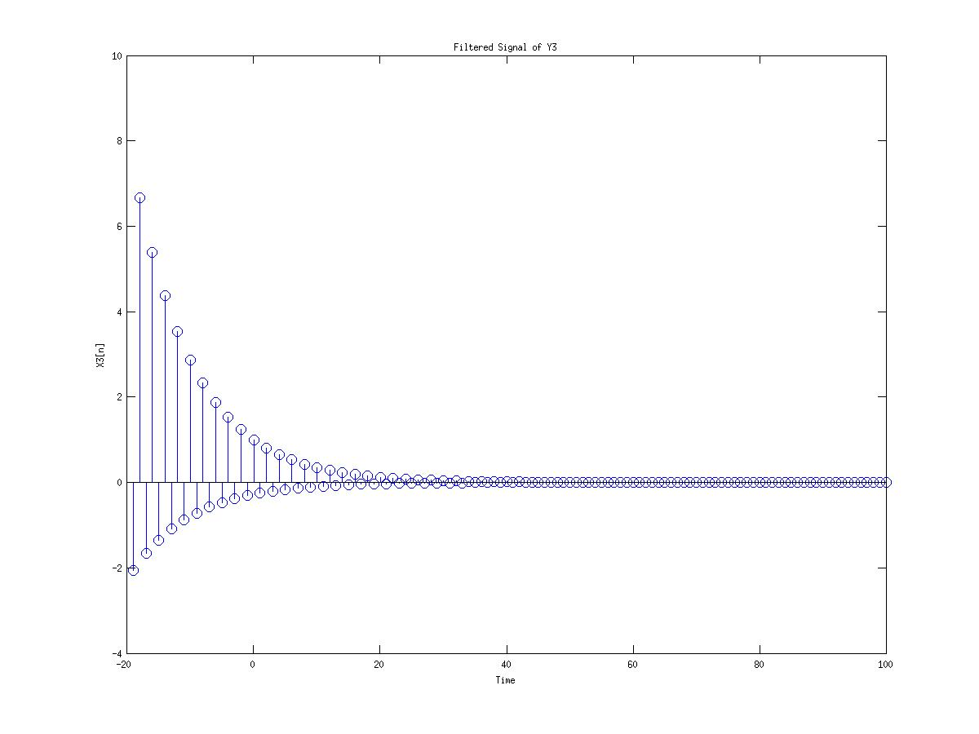
figure(3.4b3)
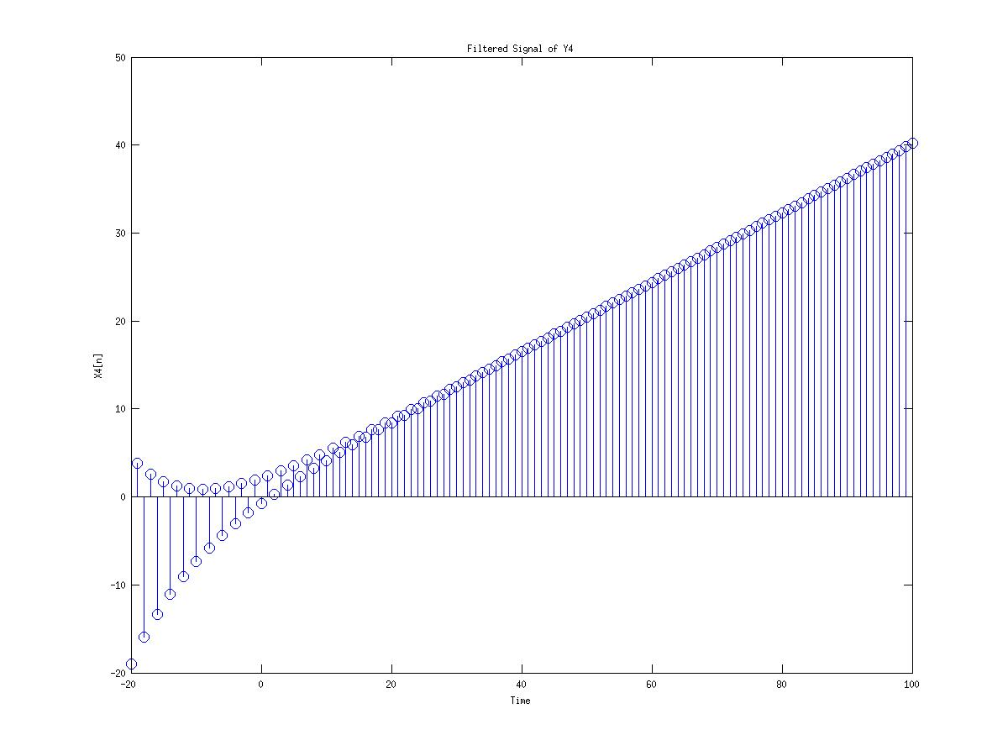
figure(3.4b4)

c.)
Code:
%Problem 3.4 (c)

disp('Problem 3.4(c)')

n = -20:100;
x1 = exp(j*(pi/4)*n);
x2 = sin(n*(pi/8) + pi/16);
x3 = (9/10).^n;
x4 = n+1;

a = [1 -0.25];
b = [1 0.9];

%calculate the y function from the constant-coefficient edifference equation
y1 = filter(a,b,x1);
y2 = filter(a,b,x2);
y3 = filter(a,b,x3);
y4 = filter(a,b,x4);

h1 = y1./x1;
h2 = y2./x2;
h3 = y3./x3;
h4 = y4./x4;

figure(1)
subplot(211)
stem(n,real(h1));
title('Ratio of output to input sequence at each time index for real signal h1 = y1./x1')
xlabel('Time')
ylabel('imag h1')

subplot(212)
stem(n,imag(h1));
title('Ratio of output to input sequence at each time index for imaginary signal h1 = y1./x1')
xlabel('Time')
ylabel('imag h1')

figure(2)
stem(n,h2);
title('Ratio of output to input sequence at each time index for h2 = y2./x2')
xlabel('Time')
ylabel('h2[n]')

figure(3)
stem(n,h3);
title('Ratio of output to input sequence at each time index for h3 = y3./x3')
xlabel('Time')
ylabel('h3[n]')

figure(4)
stem(n,h4);
title('Ratio of output to input sequence at each time index for h4 = y4./x4')
xlabel('Time')
ylabel('h4[n]')

Output:

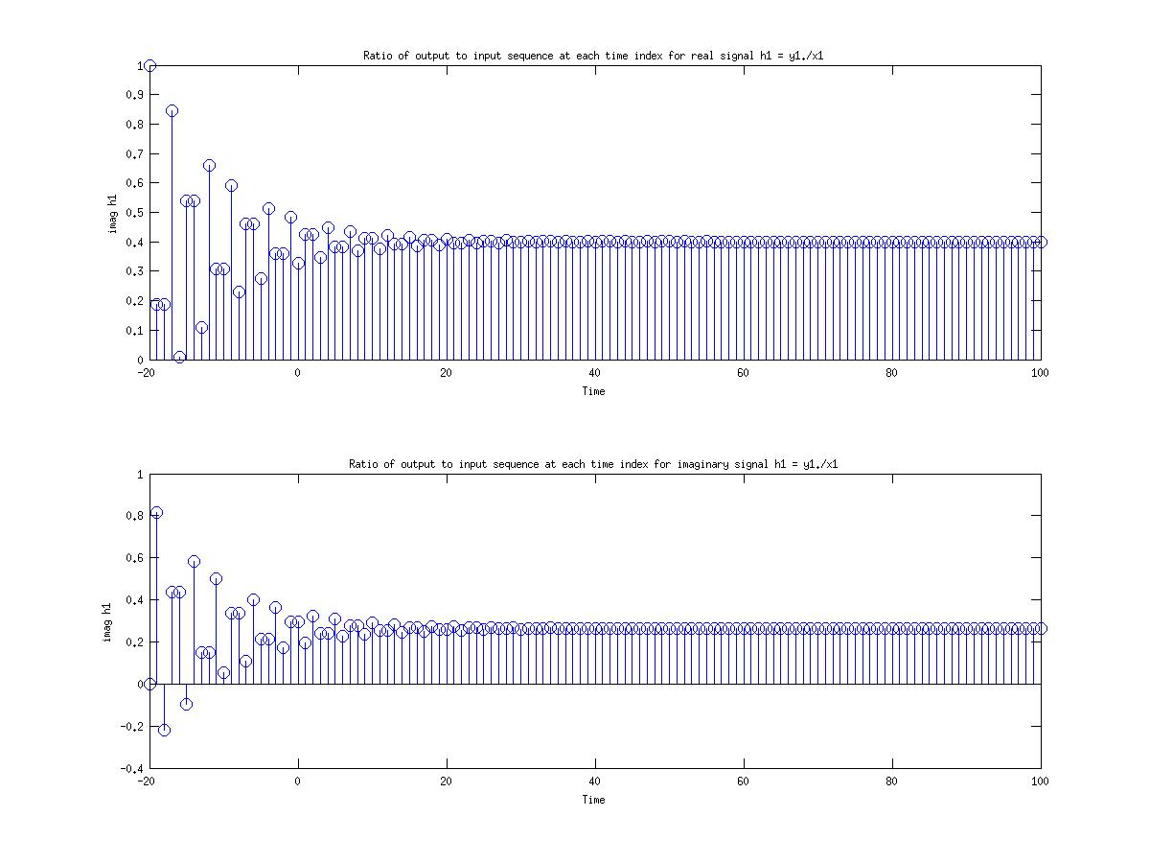
figure(3.4c1)
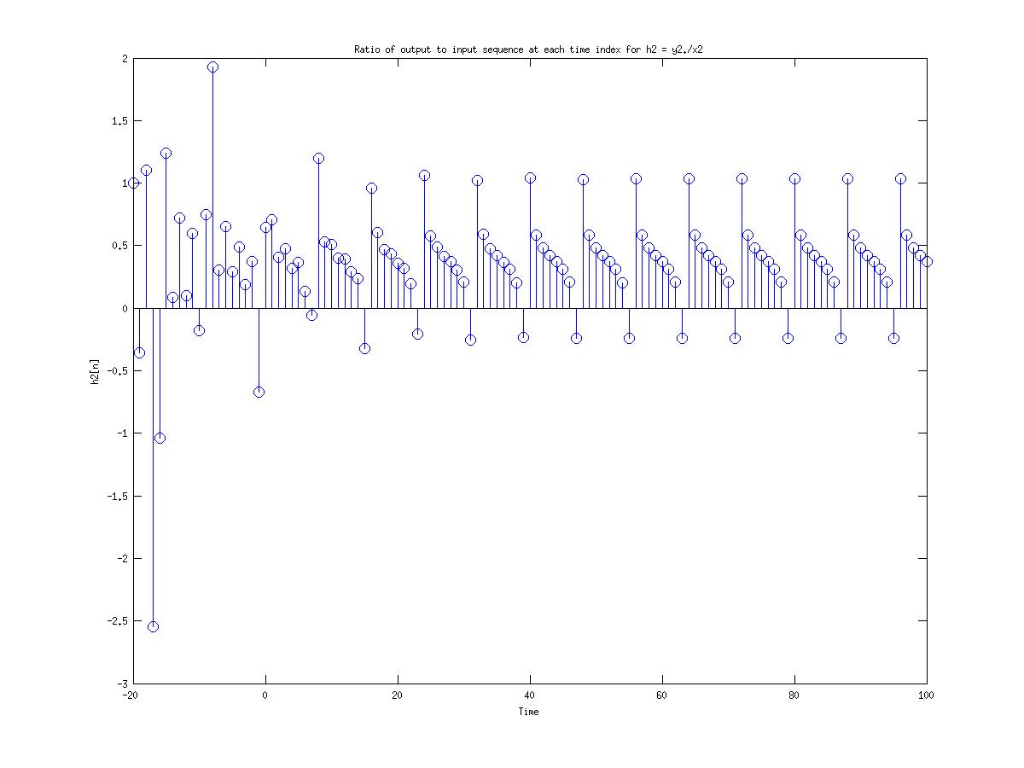
figure(3.4c2)
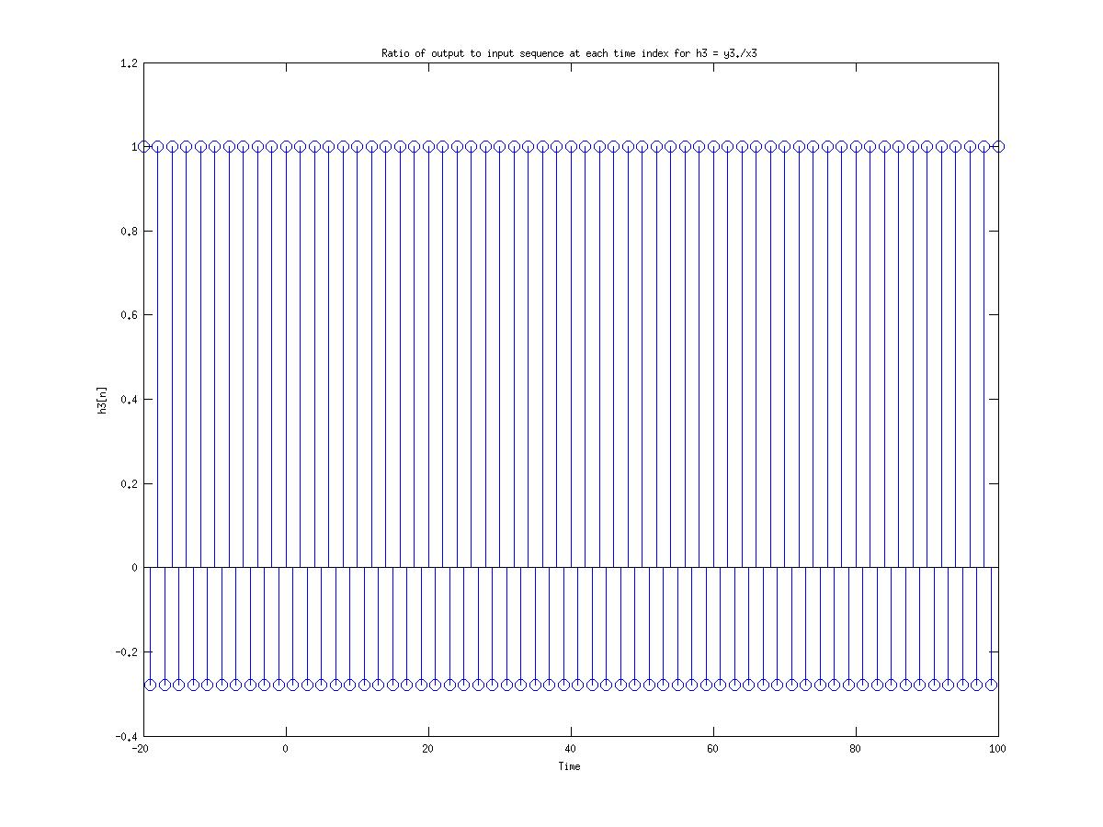
figure(3.4c3)
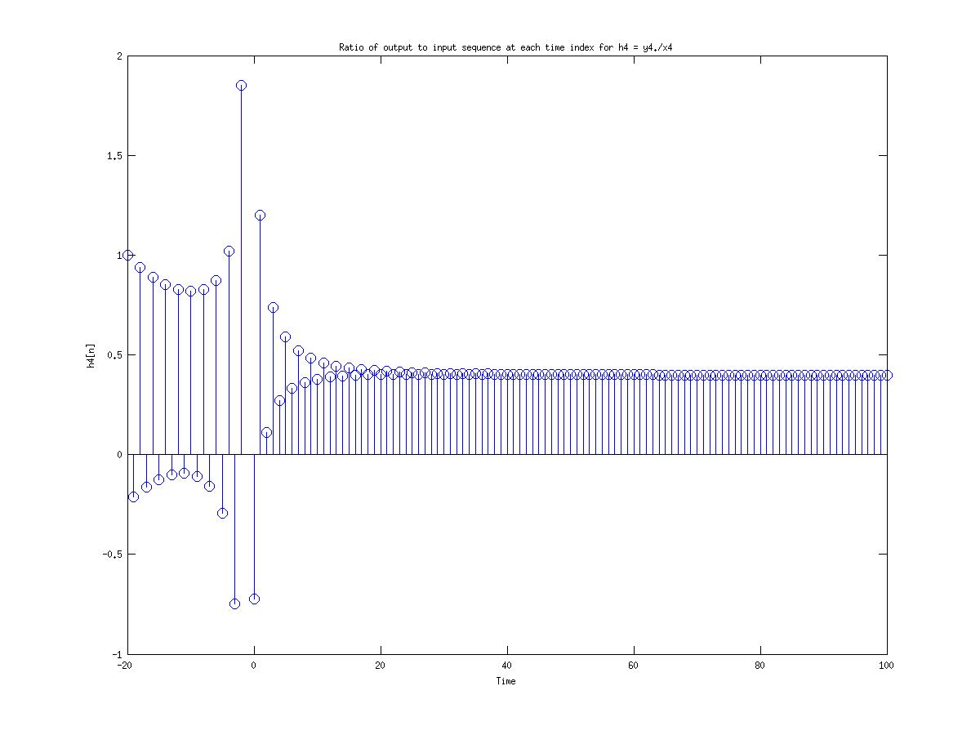
figure(3.4c4)
Custom Scripts :

imp.)
function f = imp(t)
%Daniel Noyes
%Group 11
%Unit impulse Function

f = (t == 0);

Heaviside.)
function f = Heaviside(t)
%HEAVISIDE Unit Step function

f = 1*(t>=0);

Group tasks :
For the overall Project. My team seperated into two groups due to people were procrastinating which caused the whole group to split. In my group It was me and Arnold, I did 2.7 and 3.4 while Arnold did 2.10. When we finished our work, we discused how we obtained the answers through matlab and coresponed why certain outputs for each question. We took time to understand each and every question we faced. Overall Both me and Arnold sucessful did our task and proceeded through the project.
Understanding of the Problems :
Arnold at first did not understarnd how 3.4 worked but we discussesd and both of us are now on good footing for the project. Overall both of use understand the methods achived in the project.

